RESUMATE CHANGES — 13 April 2026 Fixed

Major Issues Identified

Core Functionality

Users are unable to save changes while editing resumes. 

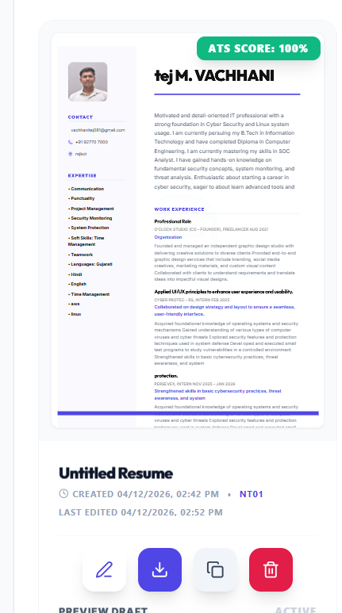

Several sections do not behave reliably, affecting overall usability. 

Validation Done:
- File Diagnostic: Clean
- Full client production build: Successful

User Experience (UX) Problems

The “Start Building” button is non-functional, creating immediate confusion. 

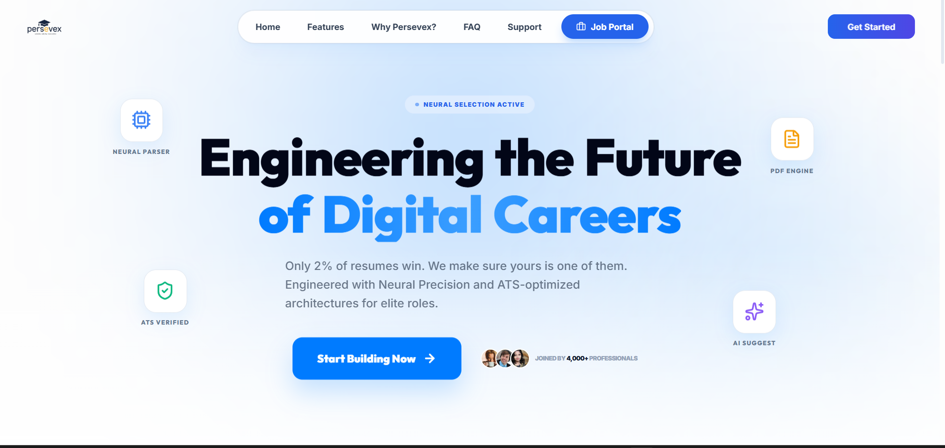

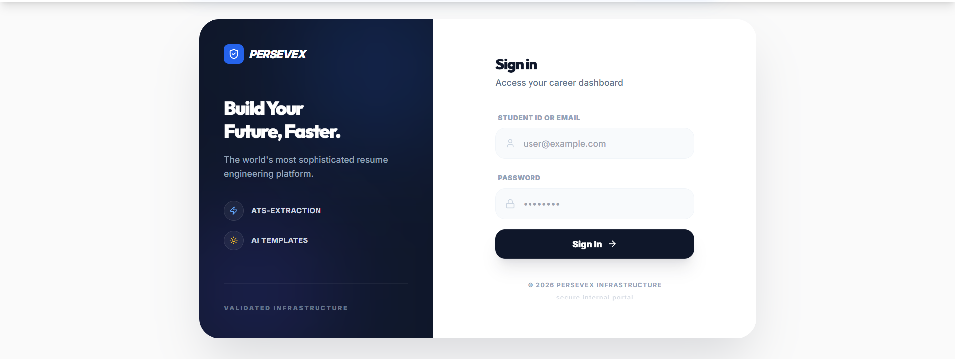


First screen lacks clear guidance or onboarding, leaving users unsure of next steps.
I have add quide text so the user know what to do next
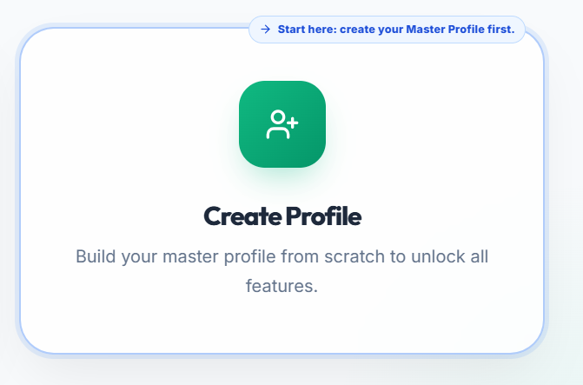
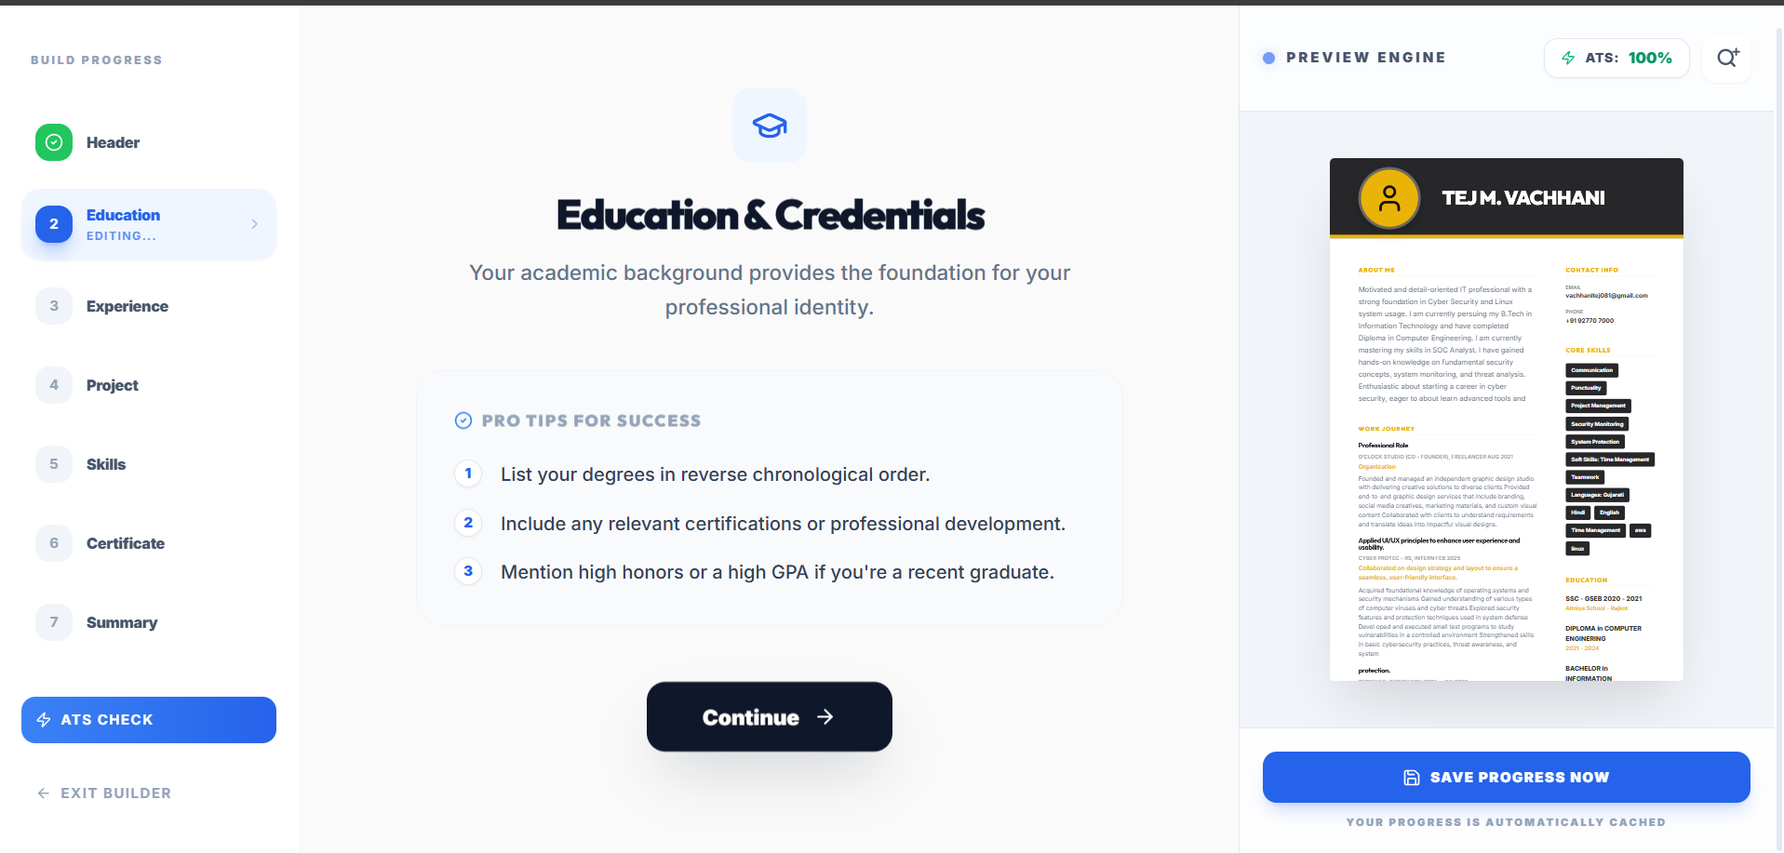

Sections exist but are not intuitive, requiring trial-and-error to understand.
What was improved:
- Builder sections now include explicit “what to do now” guidance
- Section naming in builder is clearer
- Templates screen now tells users exactly what to do
- Student dashboard now has a quick navigation guidance strip
- Added “complete profile → create/edit resume → preview/download” guidance plus direct shortcuts:
- Added your requested report subsection
- Here is the photo of solved

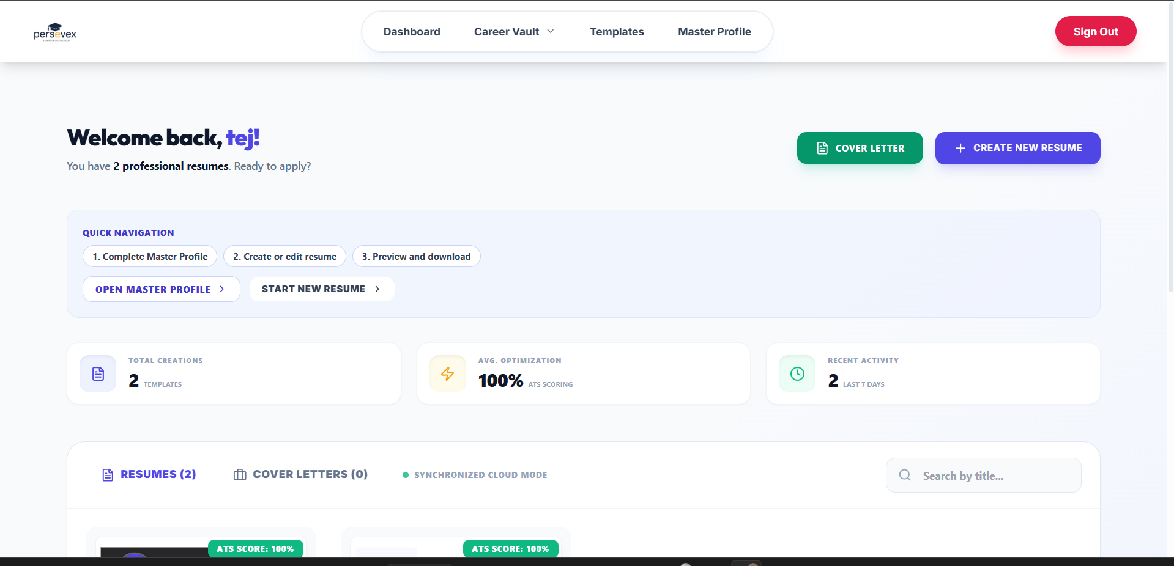

Interface & Visibility


Resume preview panel is too small, making text difficult to read.

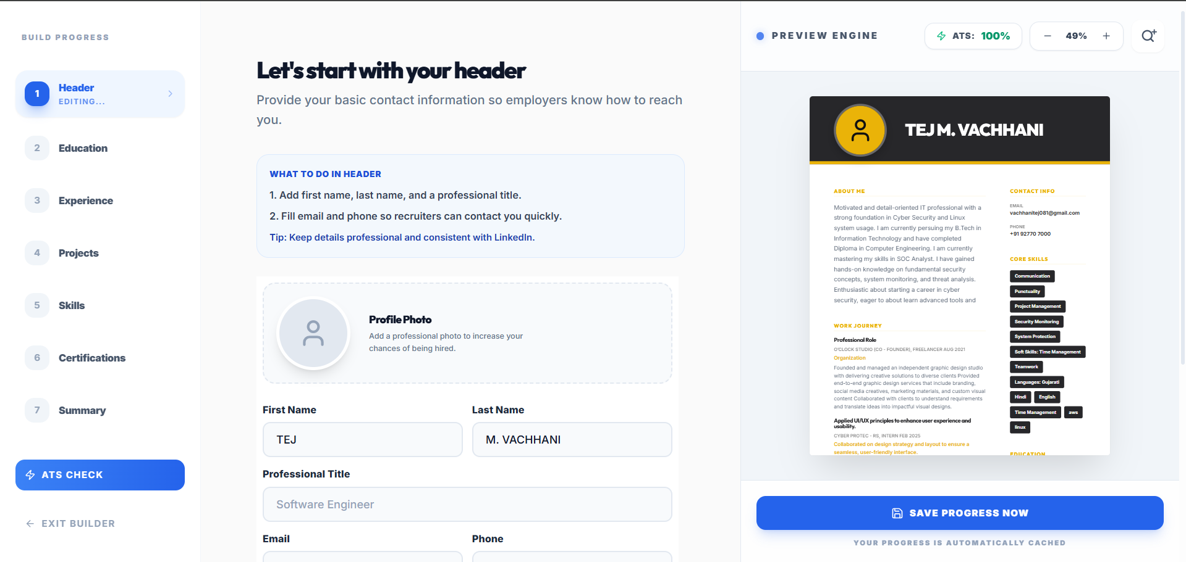

- UI lacks structure and hierarchy, reducing clarity.
What I changed:
- Added a clear hierarchy/orientation strip at top of builder workspace
- Shows:
- Current section (step + label)
- Progress bar with percent
- Next action guidance text

- Added explicit section context tag to each form step
Now each step shows a small section badge like 2/7 · Education before the title.

- Strengthened visual content hierarchy inside each step
Wrapped inputs in a dedicated “Section Editor” container so content is visually grouped and easier to scan.

Design Consistency

No constraints on:

Text length
Number of skills
→ Leads to broken layouts in final PDF output.

Broken layout in the pdf fixed and the content view properly and clearly

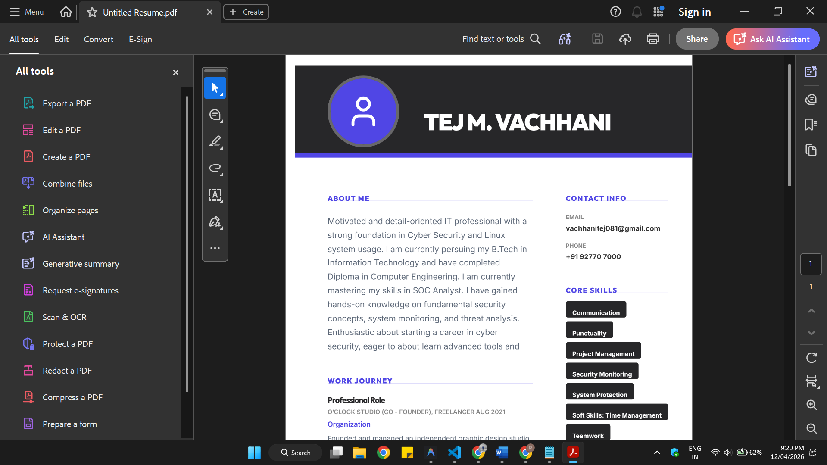

Navigation & Information Architecture

“Master Profile” is misplaced in the navbar and disrupts flow.

1) I have change the position of the master profile and the other button in the top navbar which follow the sequence and the process flow like first is dashboard > then master profile so student create the master profile > template to select the template and edit > in the last job portal to apply for job using our resume template

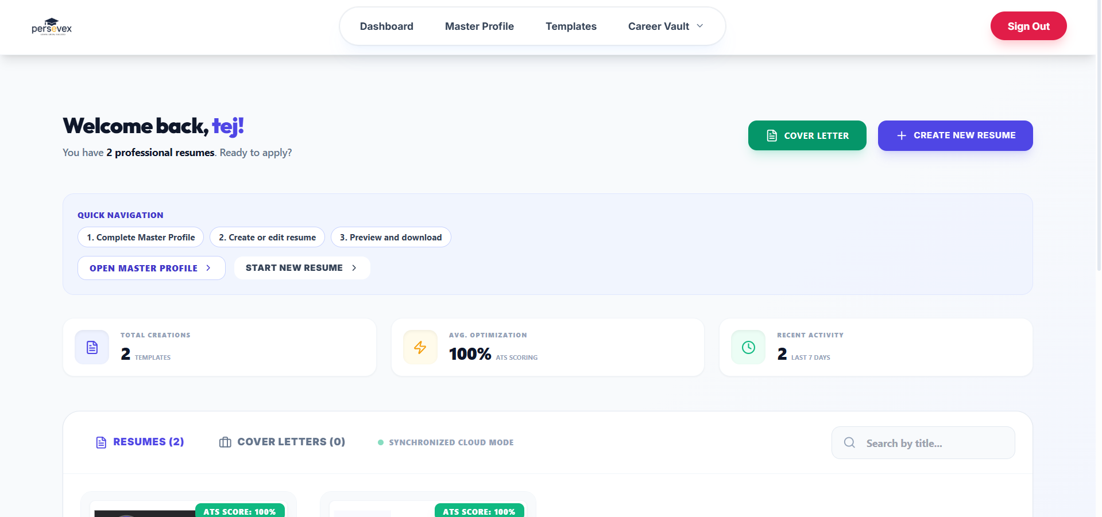

No clear separation between:

Templates
User-created resumes

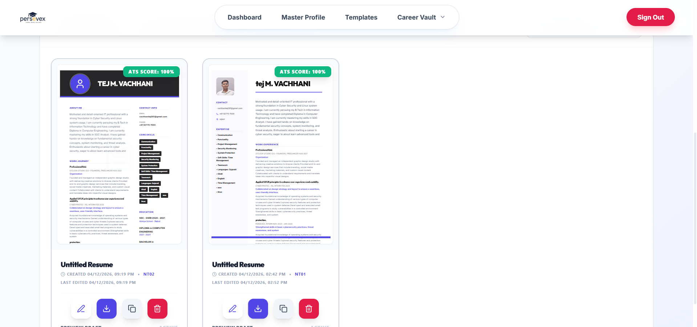

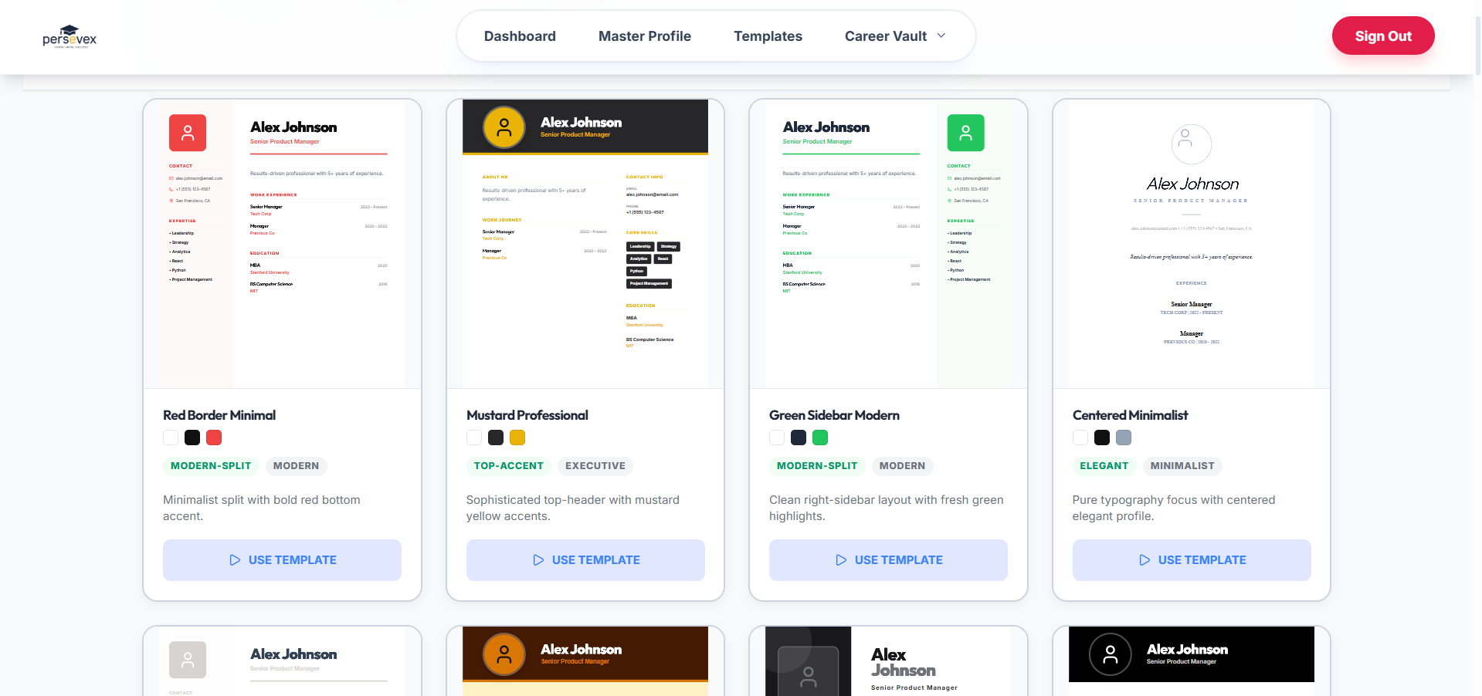


Visual & Technical Issues

Initial loading screen shows UI artifacts/glitches.
Overall app lacks a professional SaaS-grade polish.
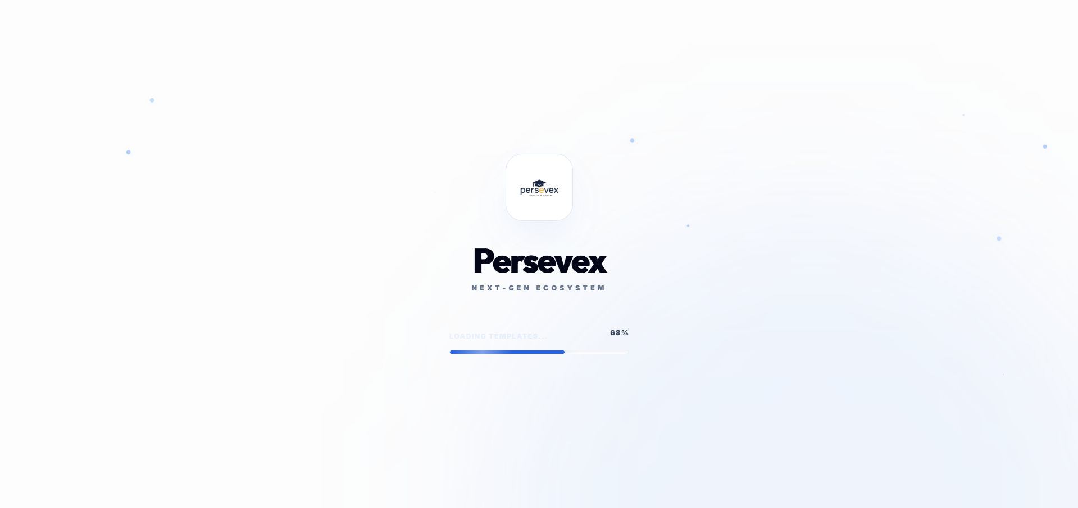

1. Initial Loading Screen UI Artifacts/Glitches The UI glitching effect was caused by the background particle effects internally recalculating random sizing and positional variations 30 times a second during the progress setInterval loop. I refactored the loading screen to securely stash those properties behind a useState hook. The loading screen animations and particles will now consistently and smoothly render without any flickering or jittery artifacts.

2. Lack of Professional SaaS-Grade Polish To rapidly uplift the SaaS-grade polish natively, I directly enriched your global index.css by:
Creating a sophisticated ambient mesh radial gradient using your primary environment colors spanning globally across the body background. This subtle glow transforms flat pages into dynamic, premium interfaces commonly found on enterprise applications.
Setting custom CSS ::selection variables that use the core accent colors to create aesthetically pleasing uniform text highlighting.

Required Fixes (Priority-Based Action Plan)


Critical Fixes (Immediate)

Fix resume editing save functionality.
Ensure all sections and inputs work reliably.
Make “Start Building” button functional → redirect to Waster Profile.

All the things are fixed when I solve the previous issue and there is no problem

Implemented and verified the critical review fixes.

1 Start Building now routes to Master Profile
Updated landing CTA action
Aligned the alternate hero CTA route
Made the hero component use the passed CTA label consistently
2 Resume editing save flow is more reliable
Added a safe generated title fallback for insert/fallback save paths
Added an always-available Save Draft action in the builder workspace (not just side preview)
3 Sections and inputs reliability improved
Enforced controlled input fallback so section fields do not drift into undefined/uncontrolled behavior


UX & Flow Improvements

Set Master Profile as default entry point after clicking “Start Building”.

We cannot do this because first we have to check that the student is login or not from the directly website click on start building we cannot redirect it to the master profile page the login was mandatory.

Introduce clear guided structure / onboarding flow:

Step-based sections OR Clearly labeled modules
I have already add this feature in the previous changes that on each page and section there is a instruction always show that what to do and the complete flow.
For that you can refer 1.2 second problem at there I have fixed this issue and everywhere the is a flow written what to do next in systematic way
Add Inventory Section:

Displays only user-created resumes.

This inventory section is the dashboard part here user can see all the resume,
Edit dates, change name of particular resume, download, edit, view and duplicate also

Navigation Restructuring

Remove “Master Profile” from top navbar.

Replace with Profile Icon (Top Right):

Hover → Profile + Sign Out options

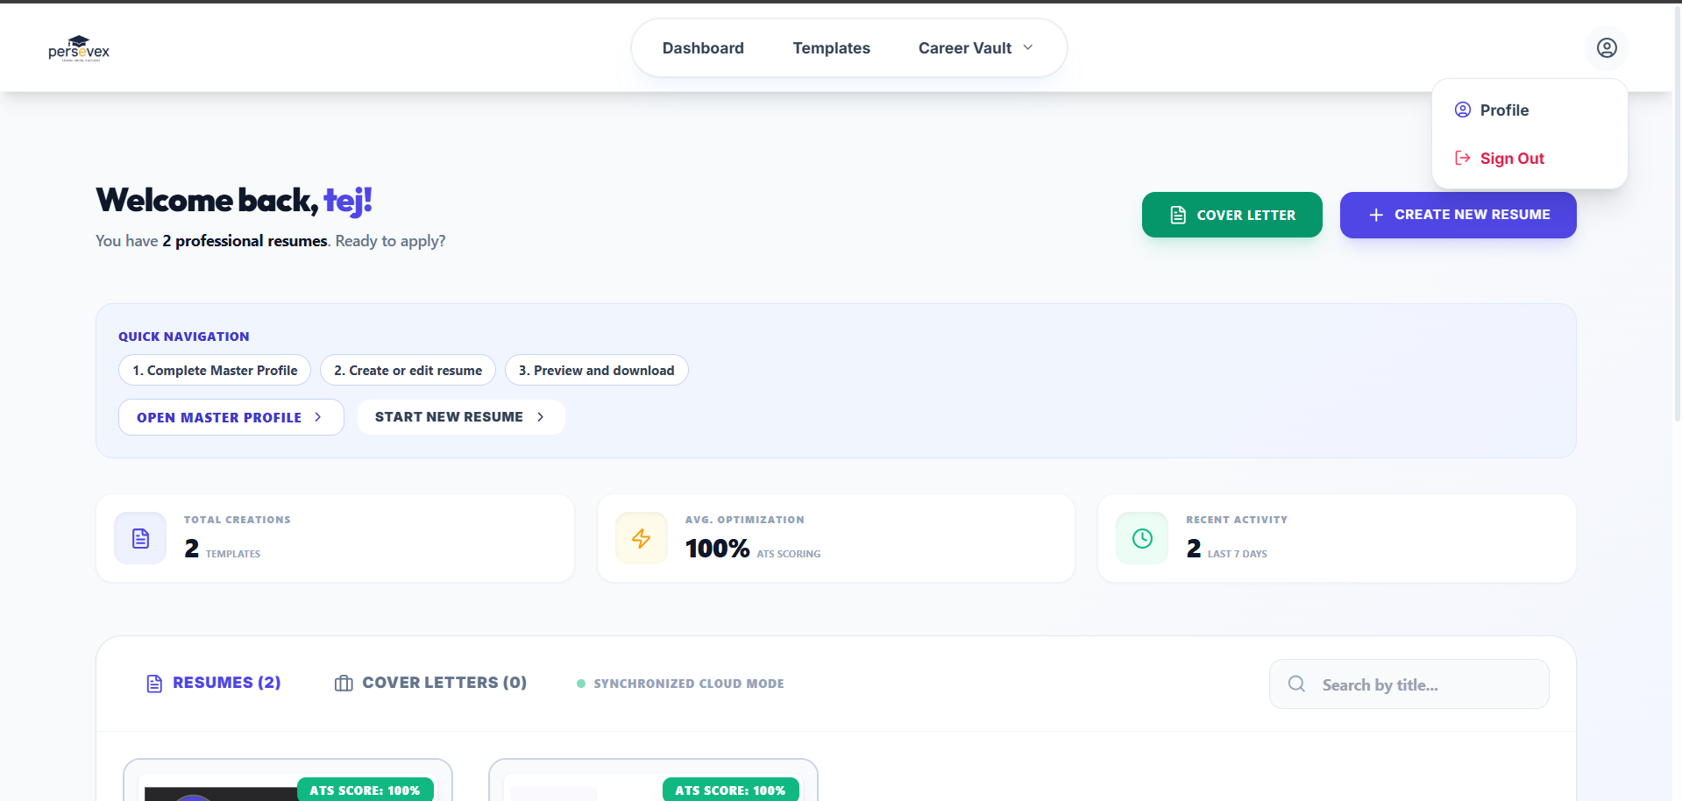


UI & Layout Enhancements

Increase preview panel size for readability.

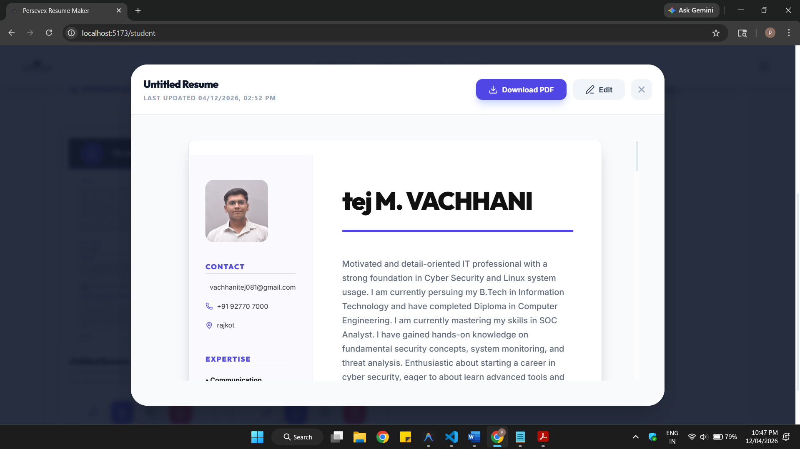

Redesign layout for:
Better spacing
Clear section hierarchy

Wider Modals: The resume and cover letter preview modals now take up significantly more screen real estate (up to 95% viewport width and max-w-7xl).
Reduced Obstructions: I removed the excess interior padding so the actual document can scale up properly within the modal frame.
Dynamic Scaling Unlocked: I updated the underlying layout logic. Previously, the system placed a strict artificial ceiling preventing the documents from scaling past 860 pixels wide. Now, on larger screens, the preview will automatically scale up by an extra 30% for maximum readability.

Minimal and clean SaaS feel

Refined Typography: The dashboard Welcome Header is now larger with tighter typography (tracking-tighter), presenting a cleaner and bolder hierarchy.
Spacing Adjustments: Increased margins to let the different sections breathe more organically.
Modernizing Quick Navigation: I completely redesigned the "Quick Navigation" area. The bulky bordered blue box has been replaced by a minimal, pill-based progression tracker (1. Complete Profile -> 2. Create Resume -> 3. Preview & Download). It features interactive hover states for the actionable steps, making the dashboard feel significantly less cluttered and much closer to enterprise-grade SaaS environments.

Content Constraints & Consistency

Add limits on:

Number of skills
Text length per section

→ Ensures consistent and clean PDF output

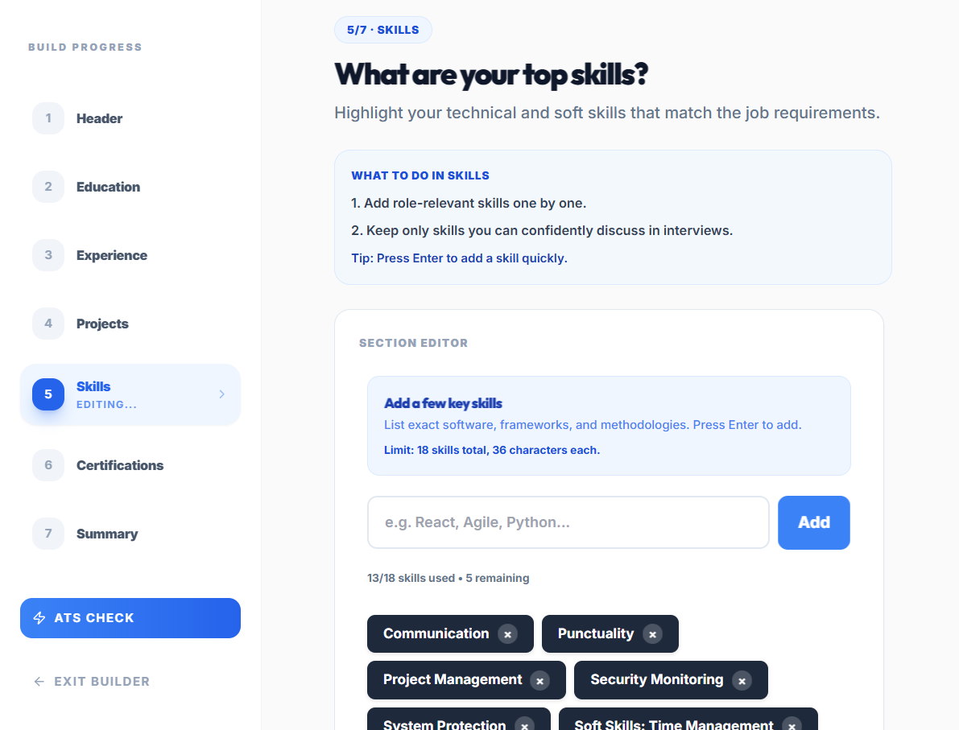

Text / Paragraph length, Skill size all are set


Feature Organization

Clearly separate:

Templates
User-designed resumes

Already solved with the previous work done


Visual Refinement

Improve overall UI to be:

Minimal
Professional
Consistent with SaaS standards
In the previous update cycles, major UI and UX improvements were implemented across the platform. The product now includes multiple new layouts, redesigned sections, and enhanced interaction flows to create a cleaner and more intuitive experience. The interface has been refined to be minimal, professional, and consistent with modern SaaS standards.

Key improvements include improved visual hierarchy, cleaner spacing and typography, more consistent components, better navigation clarity, stronger onboarding guidance, and improved responsiveness across pages. Overall, these changes significantly improve usability, reduce user confusion, and provide a more polished end-to-end experience.



Technical Improvements

Fix loading screen artifacts and glitches
Ensure smooth rendering across states

Already fix this and you can refer by seeing 1.6 Issue


Final Objective
Refine Resumate into a polished, professional SaaS product with:

Reliable functionality Clear user flow
Clean and modern UI Consistent output quality

